**School of Engineering and Information Technology**

**ASSESSMENT COVER SHEET**

|  |  |
| --- | --- |
| Student Name | Yu-Fang Wang, Wan-Ping CHIU |
| Student ID | S274768, S280854 |
| Assessment Title | Final Report |
| Unit Number and Title | PRT452 |
| Lecturer/Tutor | Dr Peter Shaw |
| Date Submitted |  |
| Date Received |  |

**Office use only**

**KEEP A COPY**

Please be sure to make a copy of your work. If you have submitted assessment work electronically make sure you have a backup copy.

**PLAGIARISM**

Plagiarism is the presentation of the work of another without acknowledgement. Students may use a limited amount of information and ideas expressed by others but this use must be identified by appropriate referencing.

**CONSEQUENCES OF PLAGIARISM**

Plagiarism is misconduct as defined under the Student Conduct By-Laws. The penalties associated with plagiarism are designed to impose sanctions on offenders that reflect the seriousness of the University’s commitment to academic integrity.

I declare that all material in this assessment is my own work except where there is a clear acknowledgement and reference to the work of others. I have read the University’s Academic and Scientific Misconduct Policy and understand its implications.*

<http://www.cdu.edu.au/governance/policies/pol-001.pdf>

Signed…………………………………………..Date………………………………………..

**\* By submitting this assignment and cover sheet electronically, in whatever form you are deemed to have made the declaration set out above.**

**Network Centric Analysis Knowledge Base Tool**

**Final Report**

**Date:**

**Client/ Supervisor: Dr Peter ShawContents**

Introduction 4

Background 4

Scope 4

1. Functional Requirement 4

2. Non-Functional Requirement 4

Methodology 4

Project Management 4

Software Architecture and Design 4

1. Prototype 4

2. Class Diagram 4

Agile Development 4

1. Use Case Diagram 4

2. Story Card 4

3. Backlog 5

4. Sequence Diagram 6

5. Version Control 6

6. Group Meeting 6

Testing 8

Introduction

Background

Scope

1. Functional Requirement
   * Searching for the best match of the keyword in the database
2. Non-Functional Requirement
   * Software quality (user friendly and simple to use)
   * Performance requirements (short response time for extracting, matching and result)
   * Security requirements (secure, non-accessible and non-editable dataset)
   * System response immediately
   * System should response accordingly
   * System should automatically validate the requirement

Methodology

Project Management

|  |  |  |  |
| --- | --- | --- | --- |
| **Roles and Responsibility** | | | |
| **Name** | **Role** | **Description** | **E-mail** |
| Yu-Fang Wang | Project Manager | Core programmer, system analysis and design | s274768@students.cdu.edu.au |
| Wan-Ping CHIU | Team Member | Recorder | s280854@students.cdu.edu.au |
| Peter Shaw | Client |  | peter.shaw@cdu.edu.au |

Software Architecture and Design

1. Prototype
2. Class Diagram

Agile Development

1. Use Case Diagram
2. Story Card

|  |
| --- |
| Story Card 001: Input data |
| As a: User |
| I want: Input meta data for variable |
| So what: user can input the meta data from the interface |

|  |
| --- |
| Story Card 002: Input data |
| As a: User |
| I want: Input meta data for topic |
| So what: user can input the keyword from the interface |

|  |
| --- |
| Story Card 003: Read file |
| As a: System |
| I want: Read in cluster from file |
| So what: system classify the data into cluster |

|  |
| --- |
| Story Card 004: List combination |
| As a: System |
| I want: List all the combination from the cluster |
| So what: system use algorithm to list the possible combination from the cluster |

|  |
| --- |
| Story Card 005: Search |
| As a: System |
| I want: Use HTTP Client to do a search |
| So what: system connect to the Google scholar via HTTP Client |

|  |
| --- |
| Story Card 006: Print results |
| As a: System |
| I want: Print results into file |
| So what: system can get the result from the search |

|  |
| --- |
| Story Card 007: Make graph |
| As a: System |
| I want: Make a graph for results |
| So what: system can make a graph according to the result |

|  |
| --- |
| Story Card 008: Make file |
| As a: System |
| I want: Make a LaTeX/ PDF file |
| So what: system can make a LaTeX/ PDF file |

1. Backlog

|  |  |
| --- | --- |
| Product Backlog | |
| Story Card 1: Input data | Priority 1 |
| Story Card 2: Input data | Priority 1 |
| Story Card 3: Read file | Priority 1 |
| Story Card 4: List combination | Priority 1 |
| Story Card 5: Search | Priority 2 |
| Story Card 6: Print results | Priority 2 |
| Story Card 7: Make graph | Priority 3 |
| Story Card 8: Make file | Priority 3 |
|  |  |
| Priority 1: High ; Priority 2: Medium ; Priority 3: Low | |

1. Sequence Diagram

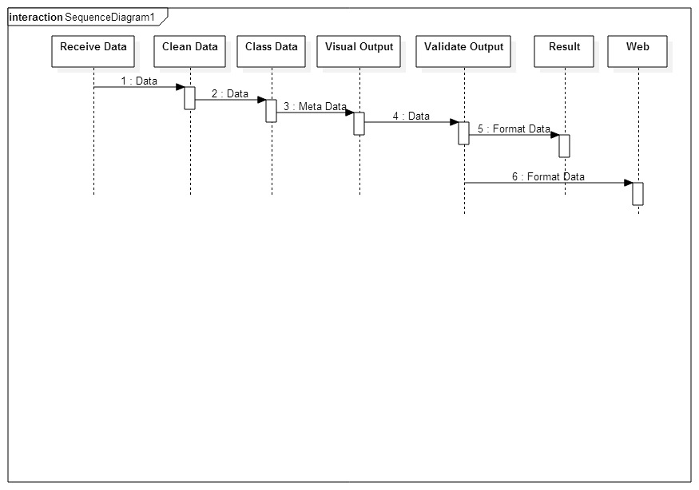

1. Version Control
2. Group Meeting

|  |  |
| --- | --- |
| Kick-off Meeting Agenda | Group Name: Transform |
| Project: Network Centric Analysis Knowledge Base Tool |
| Date: 11/08/2015 |
| Time: 9:00-9:30 |
| Location: Purple 12.3.03 |
|  | |
| Participants:  Yu-Fang Wang (s274768); Wan-Ping CHIU (s280854) | |
|  | |
| Agenda: | |
| 1. Introduction the project 2. Tools recommend: libcurl for Java 3. Use Google scholar search keywords and download the results, e.g. use the keyword “diabetes + Taiwan” 4. Graph of Kendal bool | |
| Additional Information: | |
|  | |

|  |  |
| --- | --- |
| Kick-off Meeting Agenda | Group Name: Transform |
| Project: Network Centric Analysis Knowledge Base Tool |
| Date: 14/08/2015 |
| Time: 15:00-15:15 |
| Location: Purple 12.3.03 |
|  | |
| Participants:  Yu-Fang Wang (s274768); Wan-Ping CHIU (s280854) | |
|  | |
| Agenda: | |
| 1. Functional and non-functional requirement 2. Use case, sequence diagram | |
| Additional Information: | |
|  | |

|  |  |
| --- | --- |
| Kick-off Meeting Agenda | Group Name: Transform |
| Project: Network Centric Analysis Knowledge Base Tool |
| Date: 23/08/2015 |
| Time: 15:30-16:00 |
| Location: Purple 12.1.15 |
|  | |
| Participants:  Yu-Fang Wang (s274768); Wan-Ping CHIU (s280854) | |
|  | |
| Agenda: | |
| 1. Story card 2. Backlog | |
| Additional Information: | |
|  | |

|  |  |
| --- | --- |
| Kick-off Meeting Agenda | Group Name: Transform |
| Project: Network Centric Analysis Knowledge Base Tool |
| Date: //2015 |
| Time: |
| Location: Purple 12.3.03 |
|  | |
| Participants:  Yu-Fang Wang (s274768); Wan-Ping CHIU (s280854) | |
|  | |
| Agenda: | |
|  | |
| Additional Information: | |
|  | |

Testing